Software engineering for AI

techniques

Lab assignment

NAME: Mujeebur rehman

REG NO: 192111745

DAY: 3

FACULTY NAME: DR. MARY VALENTINA

11.Draw a Class diagram for Online Voting System using CASE tools

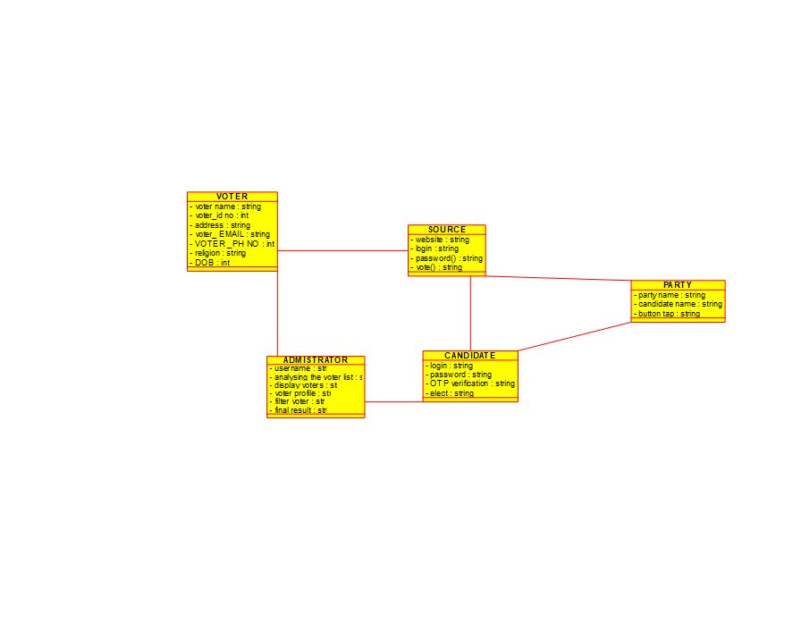

**RESULT:** Thus class diagram for online voting system is drawn and verified successful

12.Draw a Class diagram for Library Management System using CASE tools.

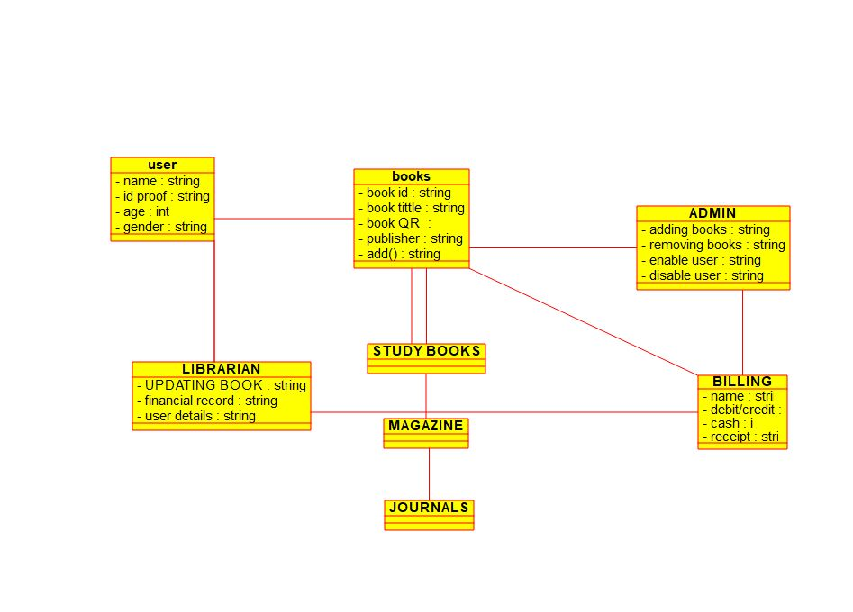

**RESULT:** Thus class diagram for library management system is drawn and verified successful

13.Draw a Class diagram for Online Shopping system using CASE tools.

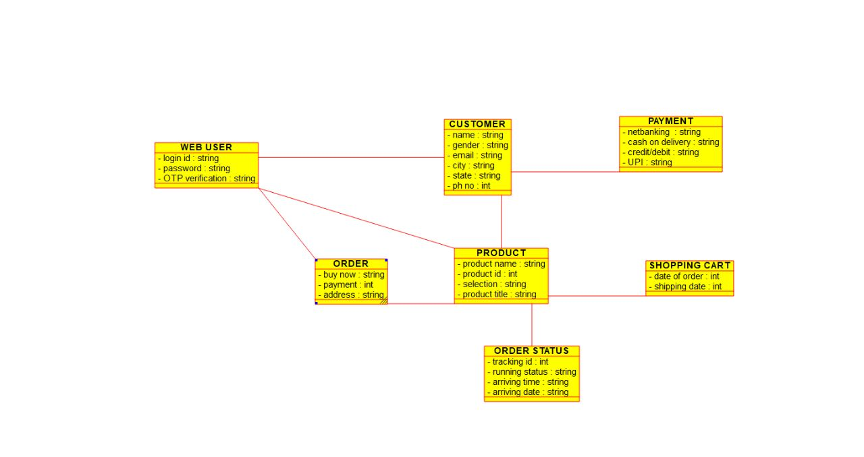

**RESULT:** Thus class diagram for online shopping system is drawn and verified successful

14.Draw a Class diagram for Online Railway Reservation System using CASE tools.

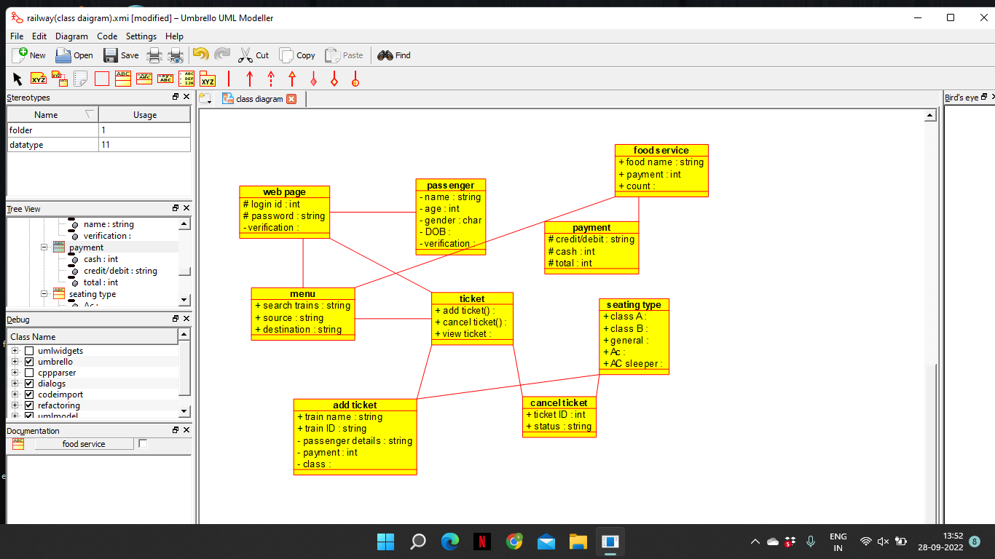

**RESULT:** Thus class diagram for online railway reservation system is drawn and verified successful

15.Draw a Activity diagram for Online Voting System using CASE tools

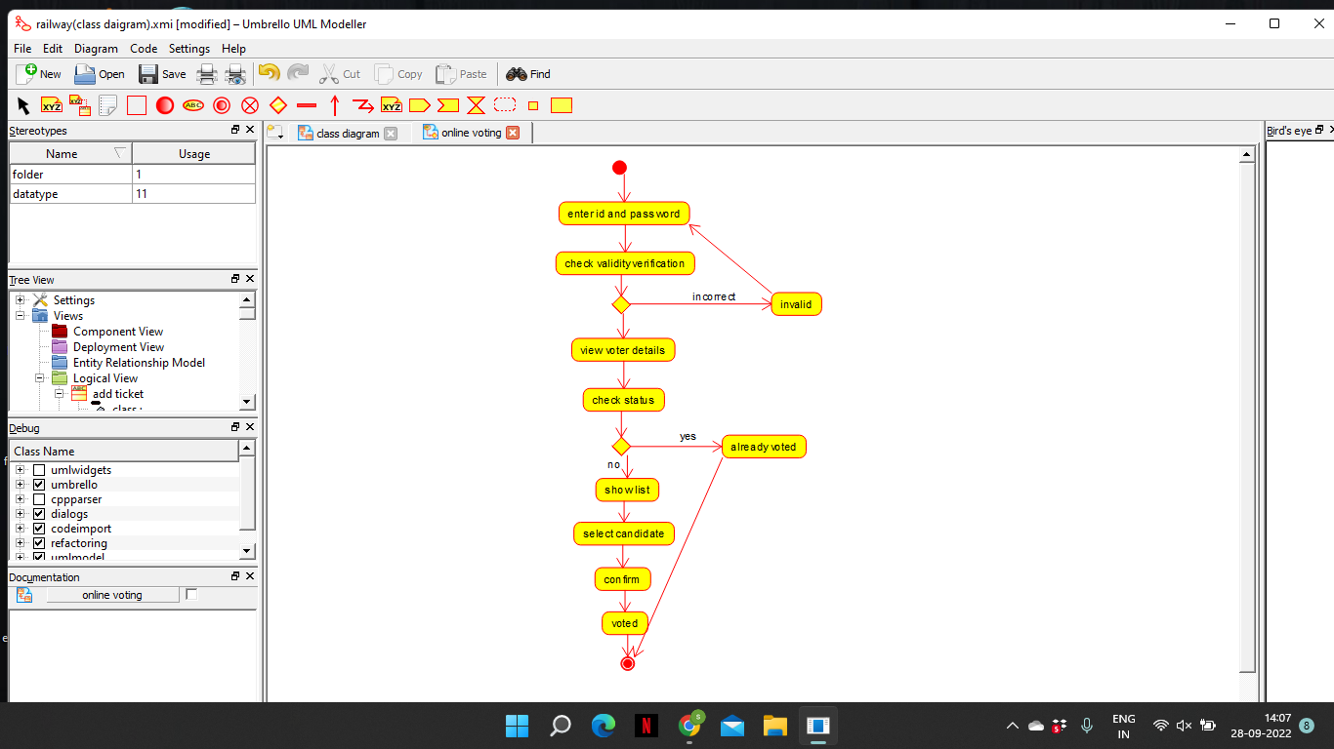

**RESULT:** Thus Activity diagram for online voting system is drawn and verified successful

16.Draw a Activity diagram for Library Management System using CASE tools.

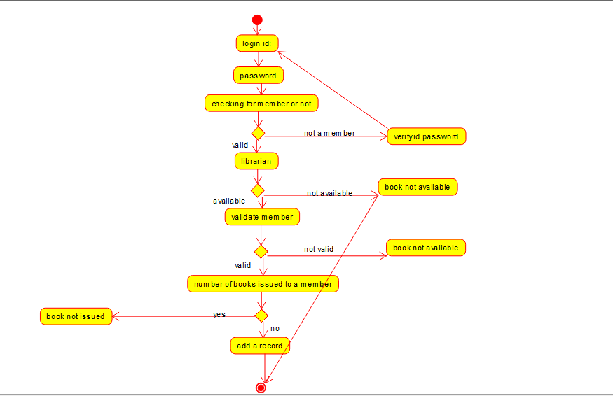

**RESULT:** Thus Activity diagram for library management system is drawn and verified successful

17.Draw a Activity diagram for Online Shopping system using CASE tools.

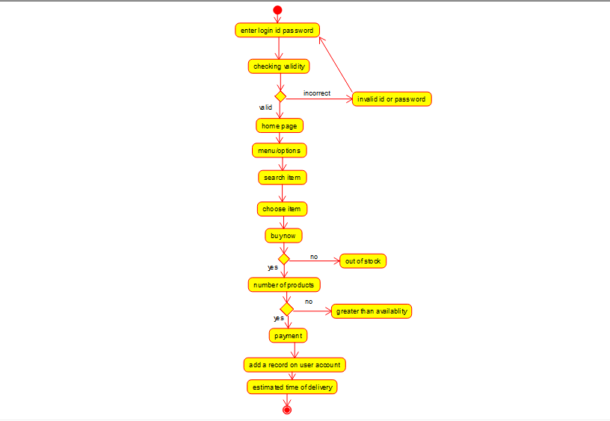

**RESULT:** Thus Activity diagram for online shopping system is drawn and verified successful